1. **Configure Classic Load balancer.**

***(Legacy — works on Layer 4 & 7)***

1. **Open EC2 → Load Balancers → Create Load Balancer → Select Classic Load Balancer.**
2. **Name your LB and choose the scheme:**
   * **Internet-facing or Internal.**
3. **Listeners:**
   * **Add HTTP (80) and/or HTTPS (443).**
4. **Availability Zones:**
   * **Select the VPC and subnets (at least 2 for HA).**
5. **Security Groups:**
   * **Allow inbound HTTP/HTTPS.**
6. **Health Checks:**
   * **Example: Protocol HTTP, Ping Path /health.**
7. **Add EC2 Instances to the LB.**

**Review & Create.**

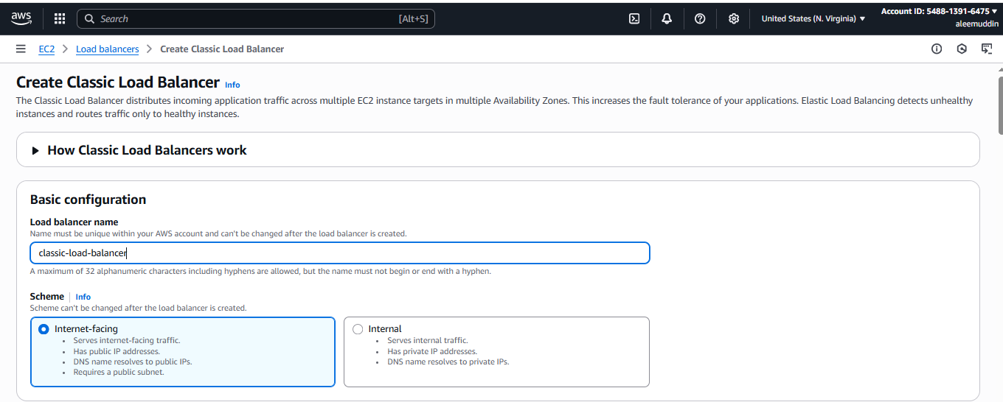

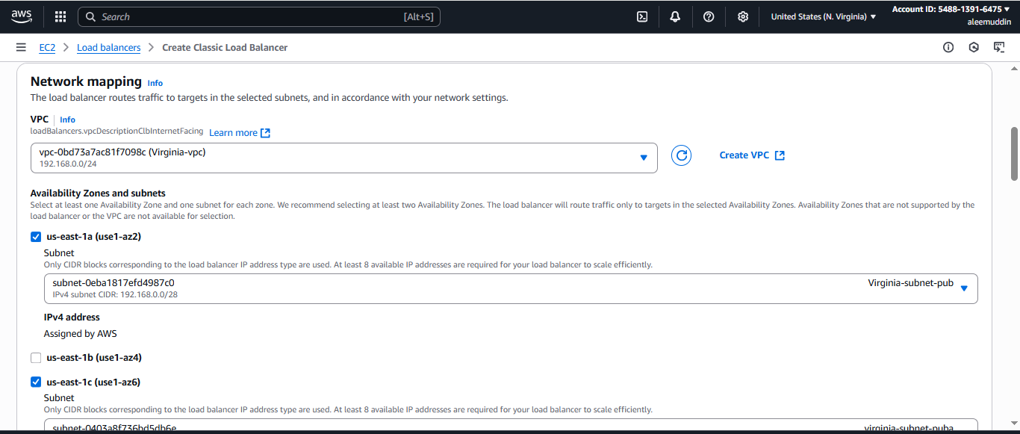

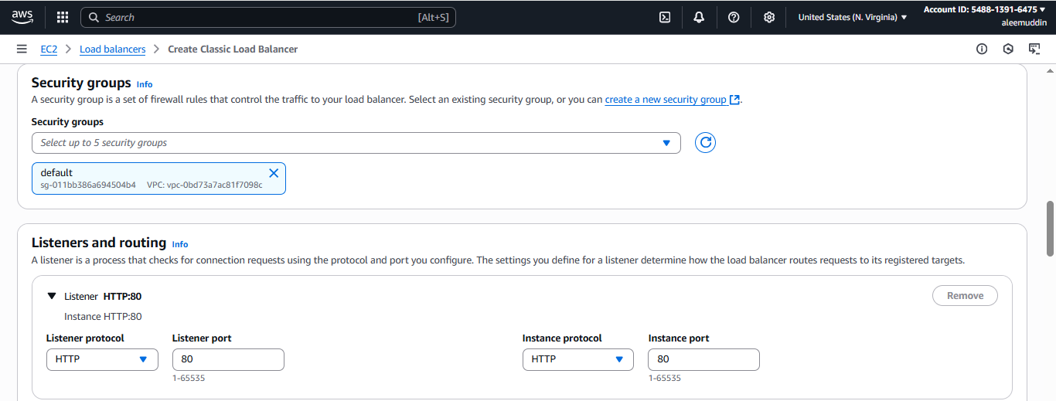

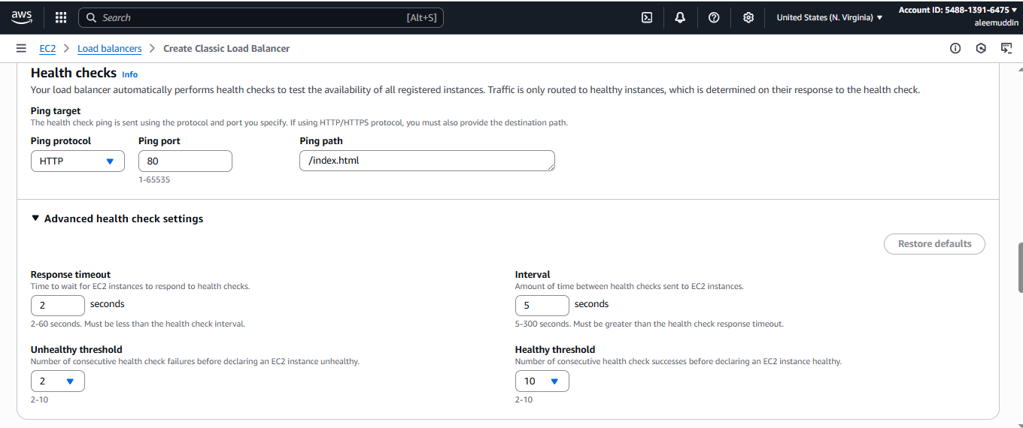

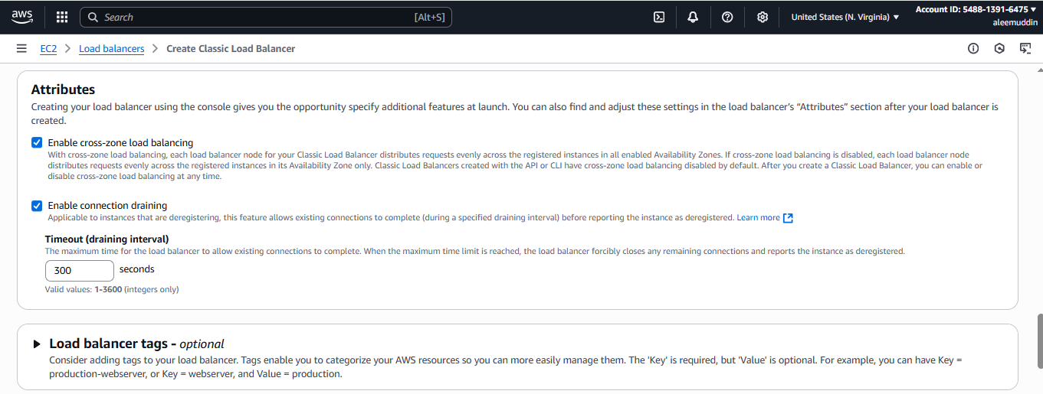

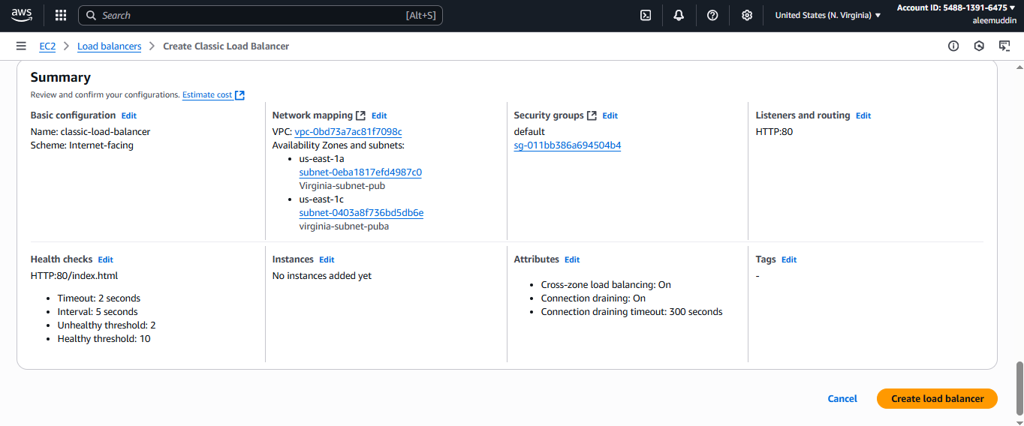

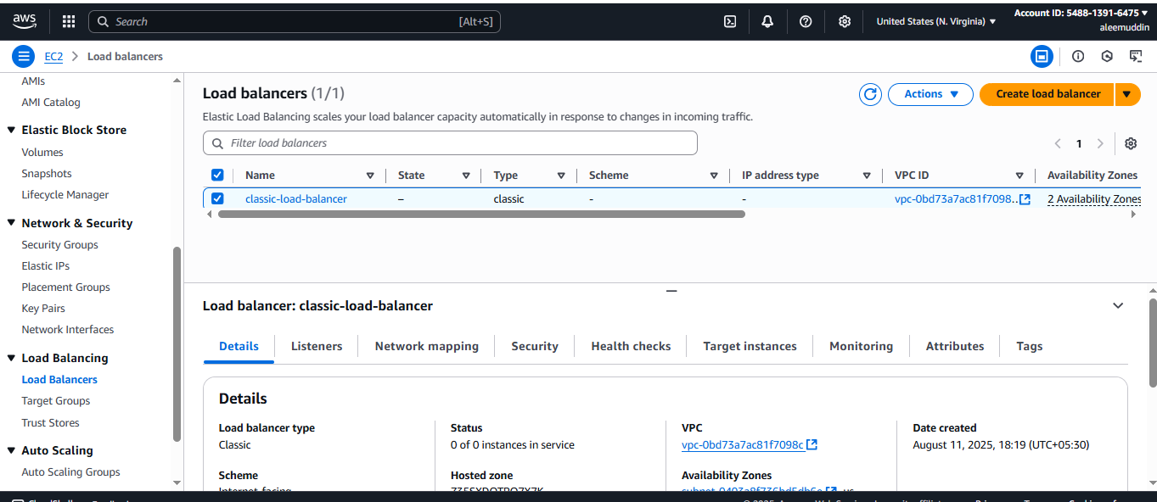

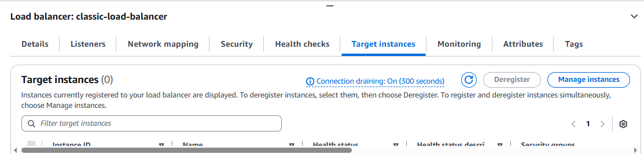

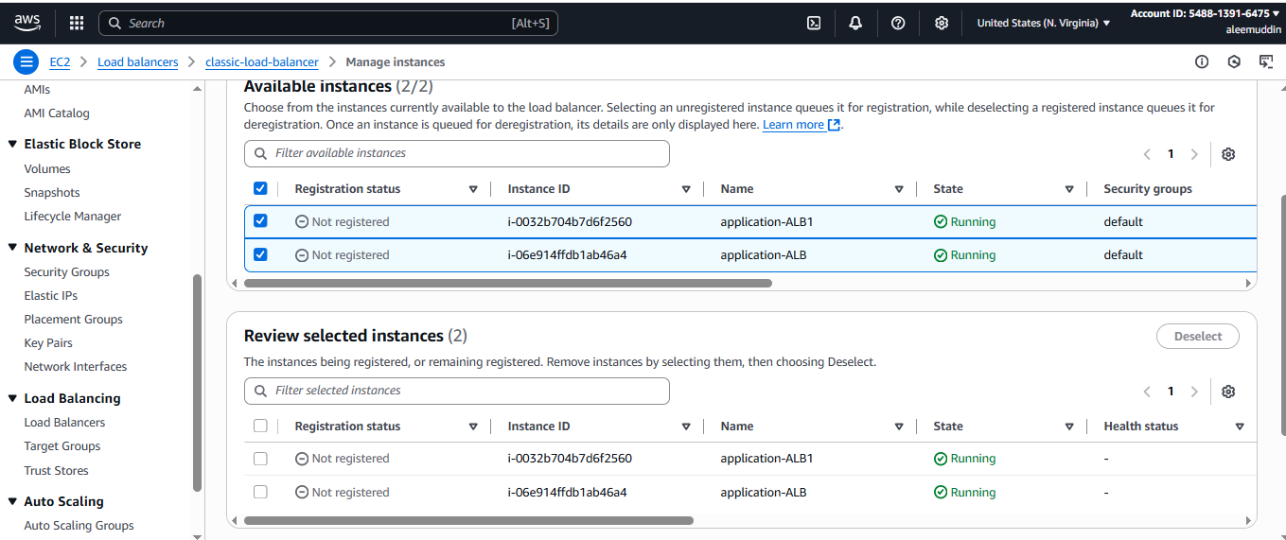

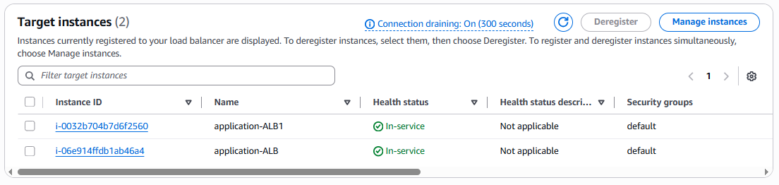

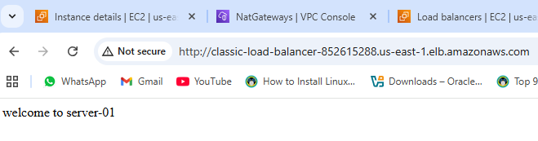

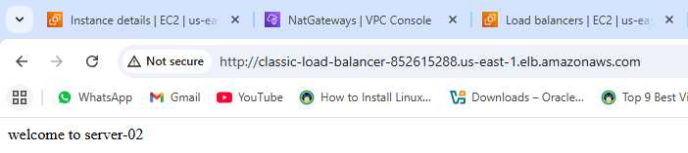

**2) Configure Application Load balancer.**

***(Modern — works on Layer 7)***

1. **Go to EC2 → Load Balancers → Create Load Balancer → Application Load Balancer.**
2. **Name it → Select Internet-facing → Scheme: IPv4.**
3. **Listeners:**
   * **HTTP (80) or HTTPS (443).**
4. **Availability Zones:**
   * **Select VPC and 2+ public subnets.**
5. **Security Groups:**
   * **Allow inbound HTTP/HTTPS.**
6. **Target Groups:**
   * **Create a new Target Group (type = Instances/IPs/Lambda).**
   * **Register EC2 instances.**
7. **Review & Create.**

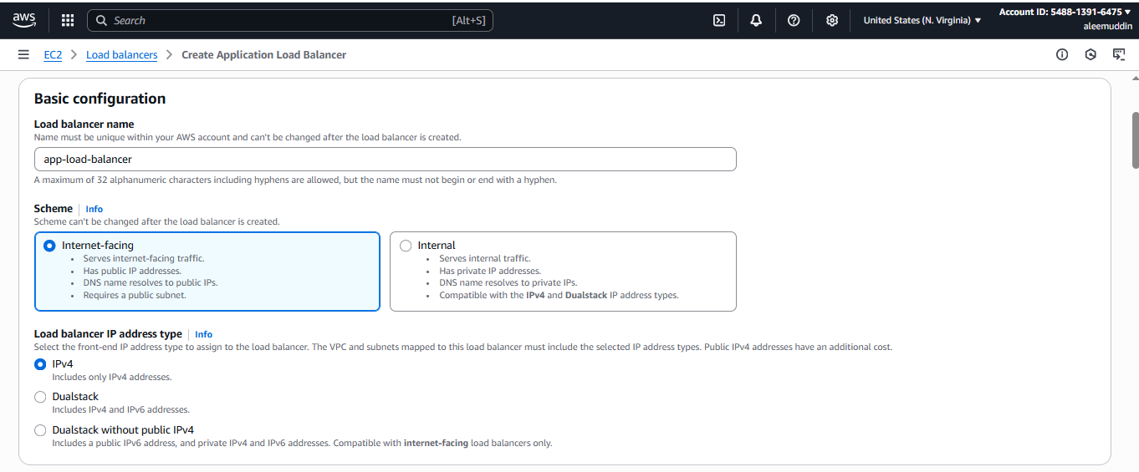

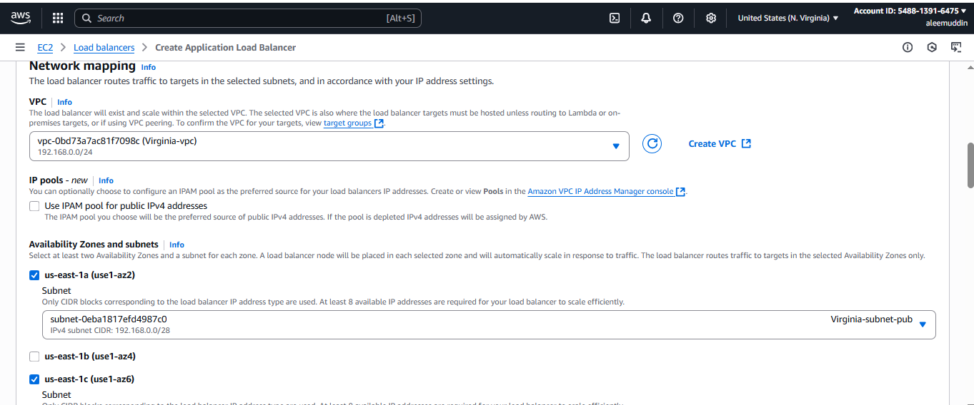

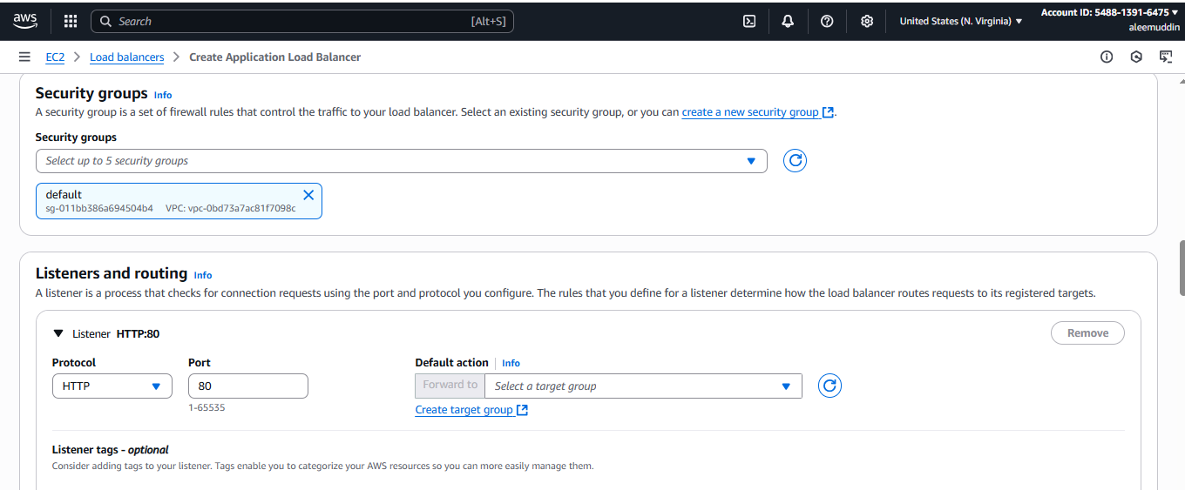

**Creating target group**

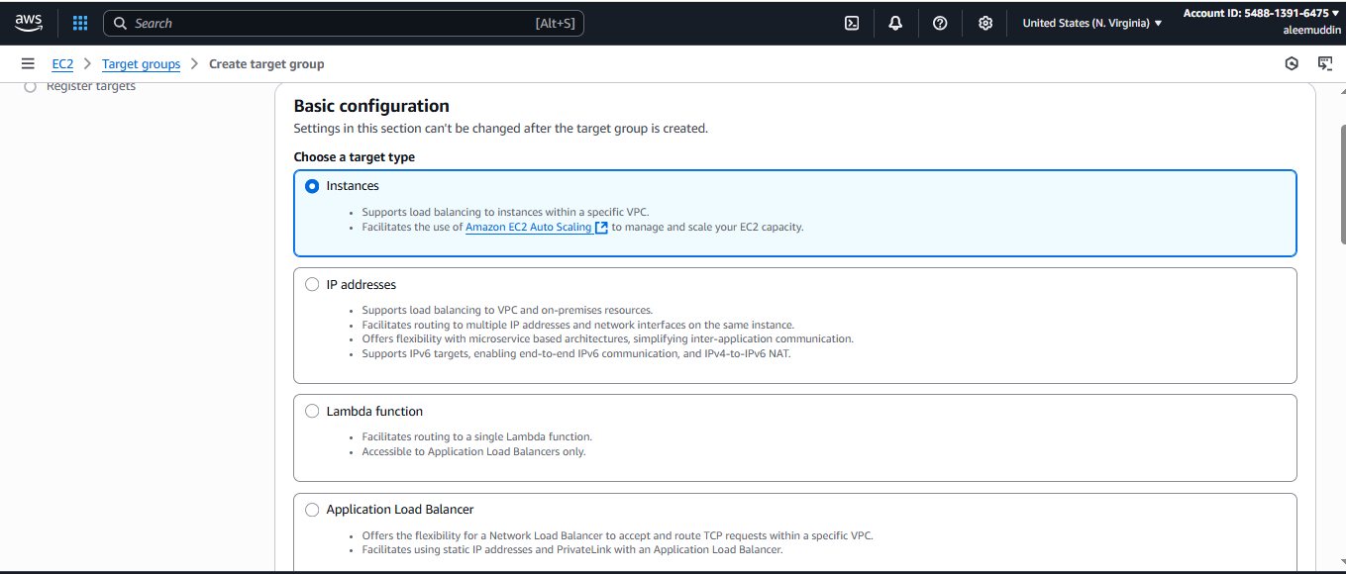

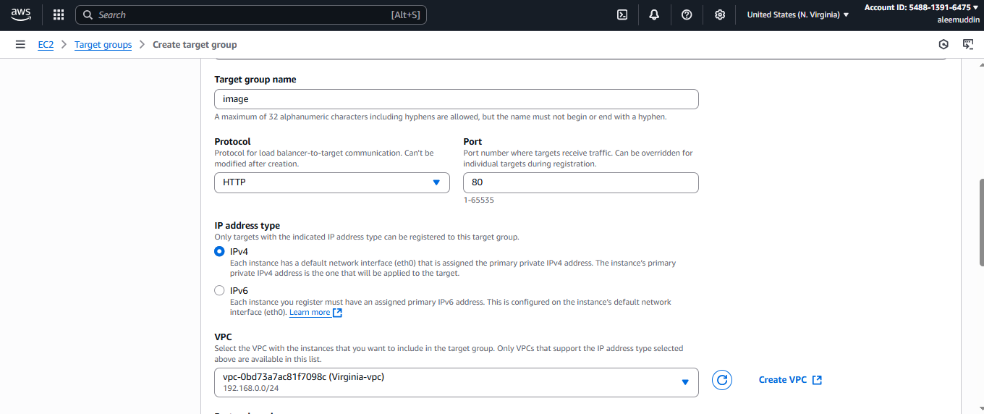

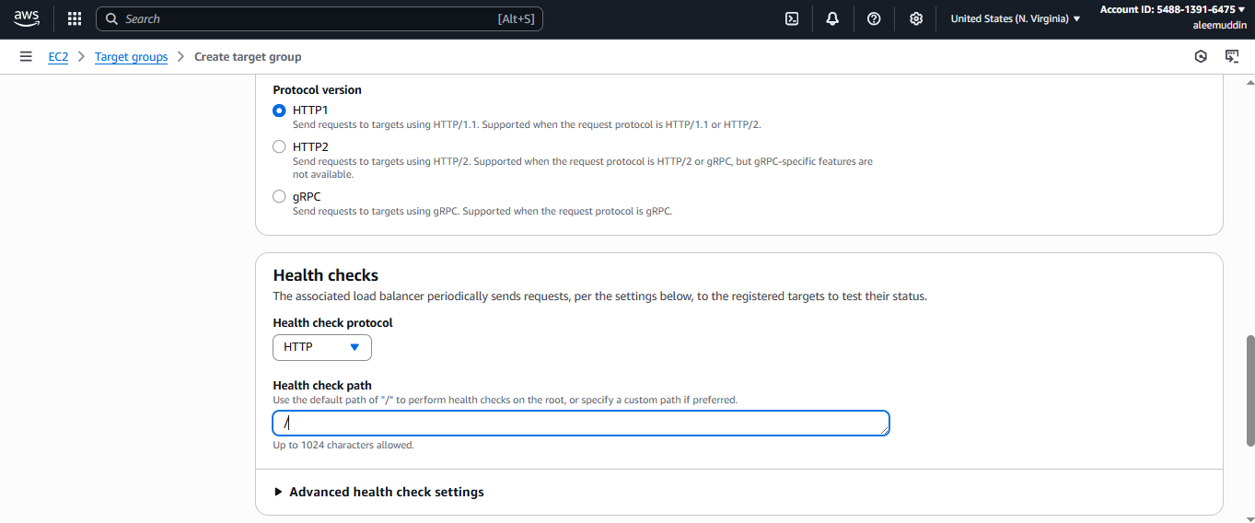

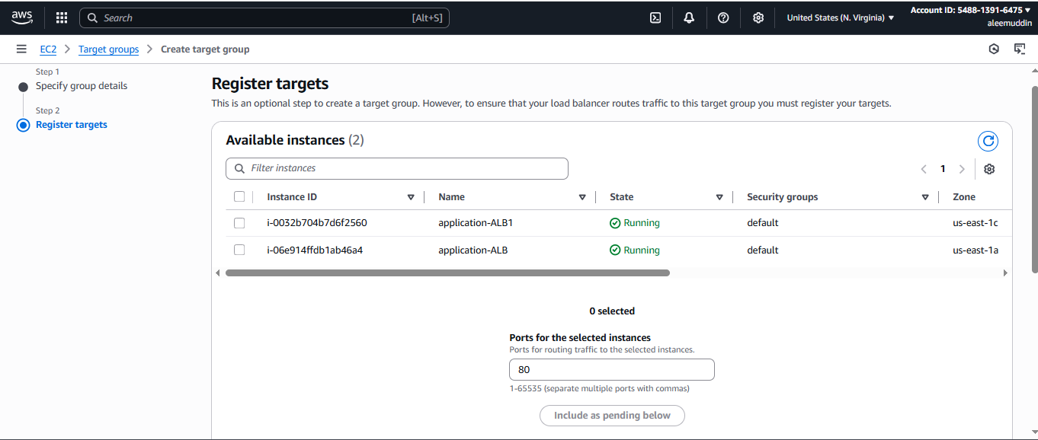

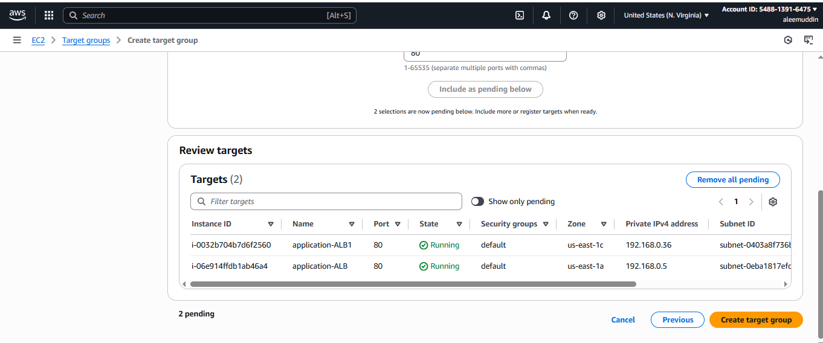

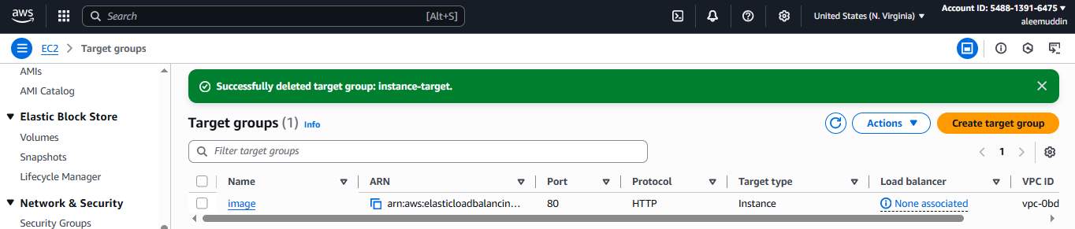

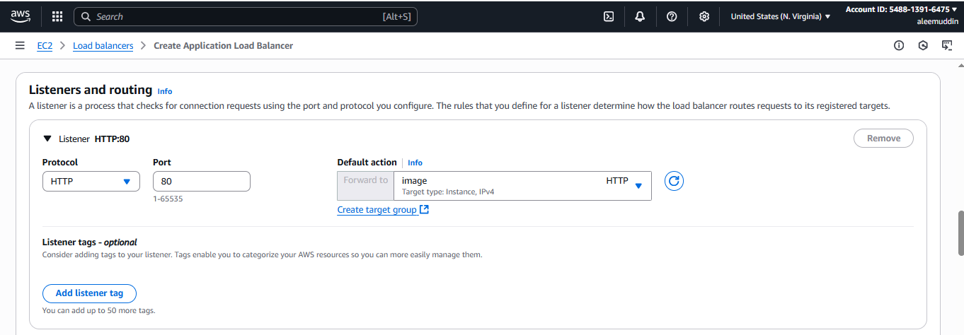

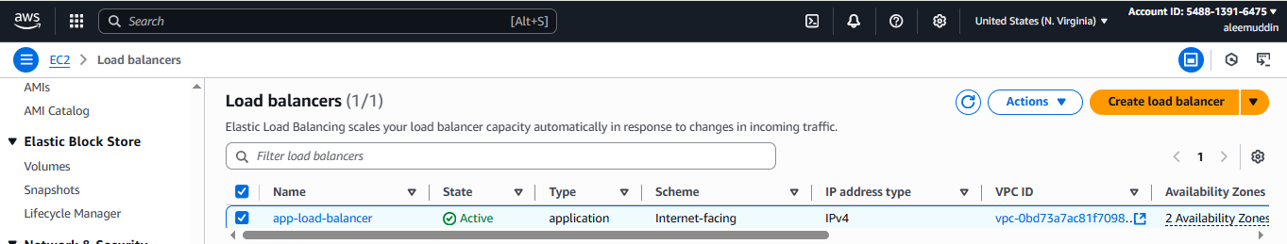

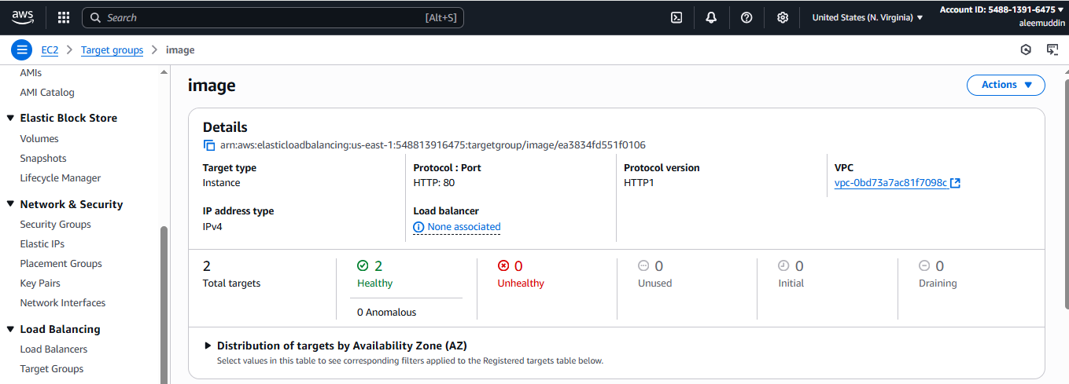

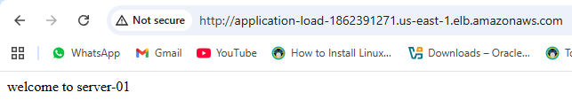

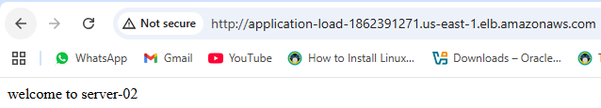

**3) Configure Network Load balancer.**

***(Layer 4 — TCP/UDP/TLS)***

1. **Go to EC2 → Load Balancers → Create Load Balancer → Network Load Balancer.**
2. **Name it → Scheme: Internet-facing or Internal.**
3. **Listeners:**
   * **TCP/UDP/TLS ports.**
4. **Availability Zones:**
   * **Choose VPC and subnets (can assign static Elastic IPs).**
5. **Target Groups:**
   * **Create Target Group with type TCP/UDP.**
6. **Register EC2 Instances.**
7. **Review & Create.**

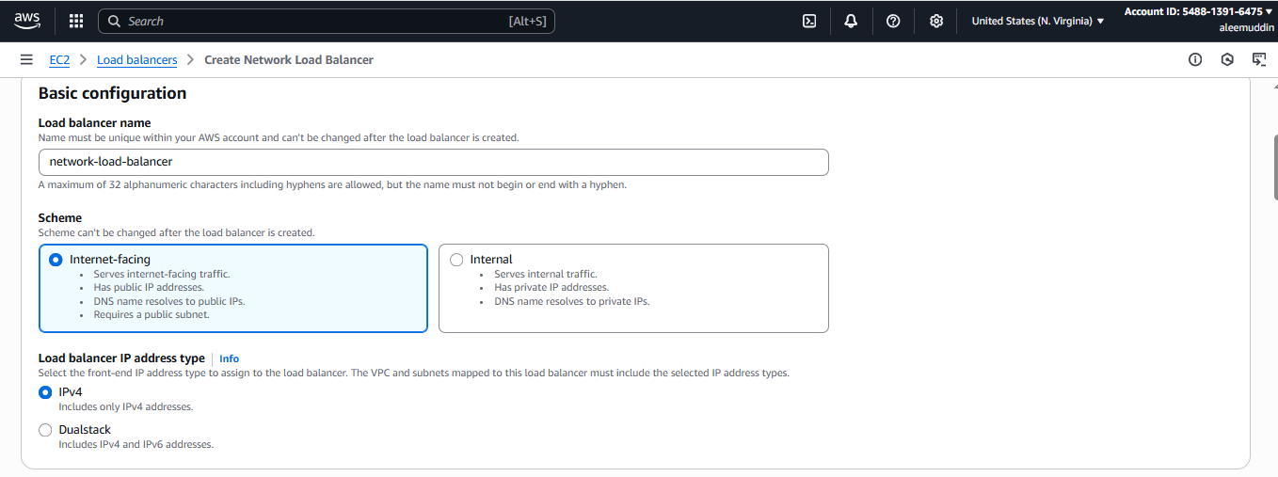

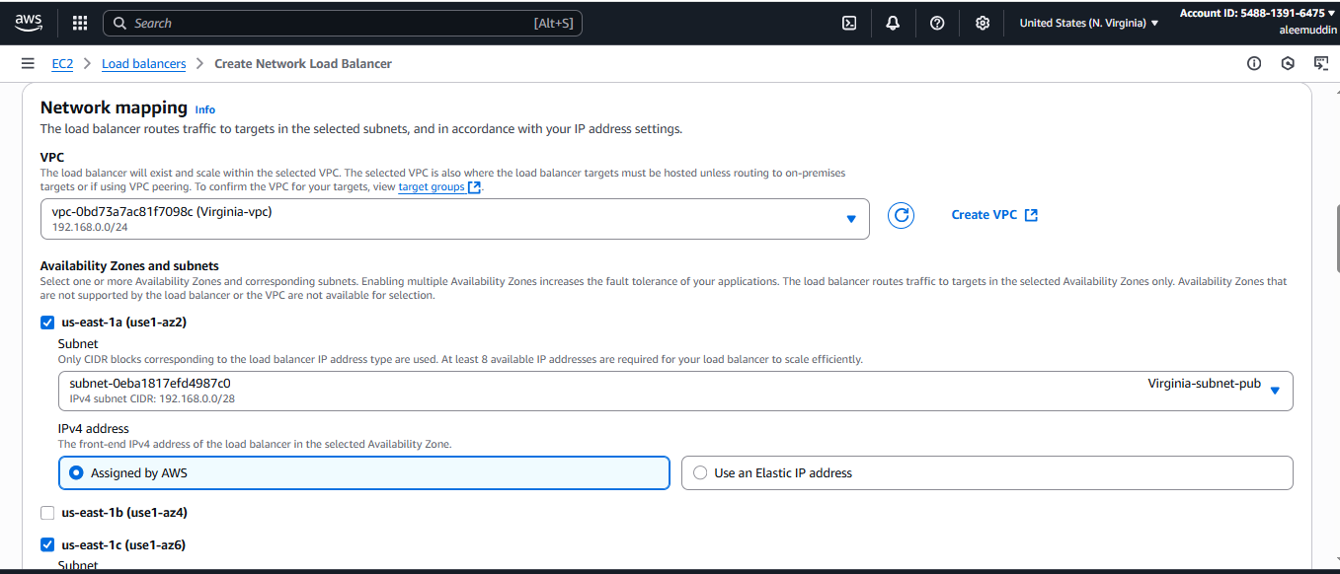

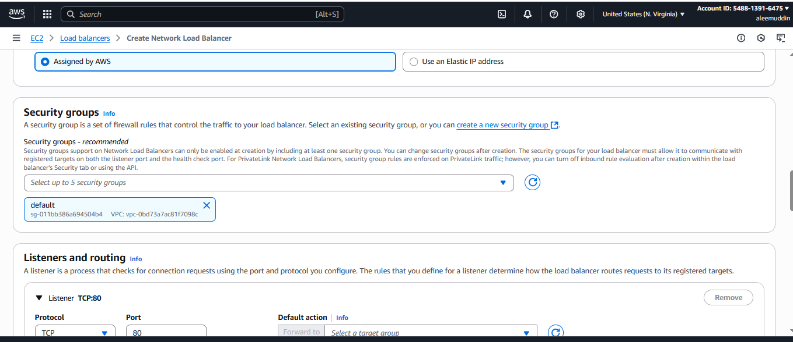

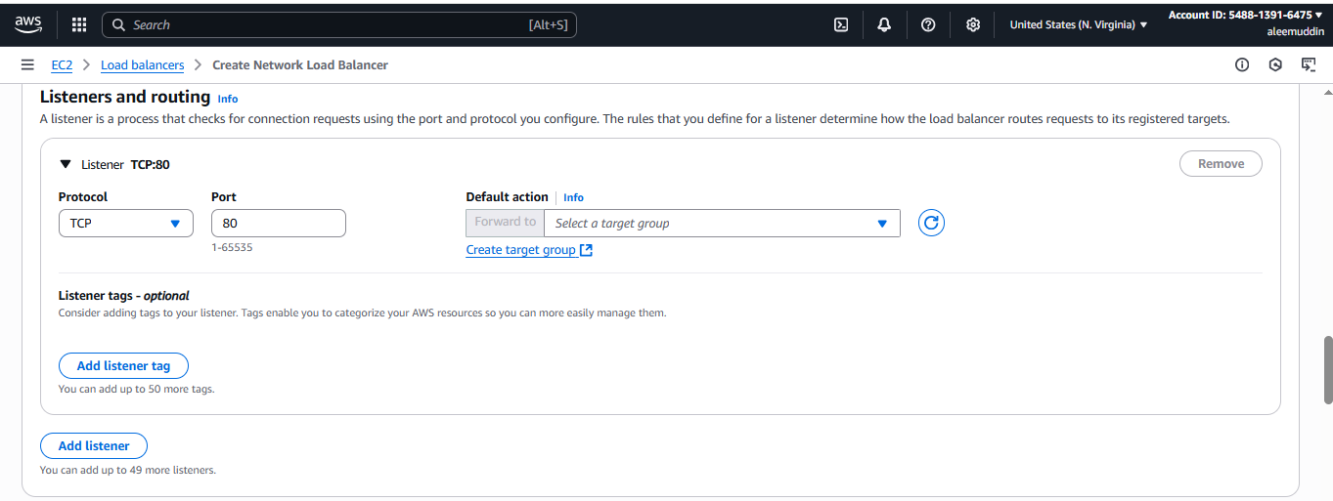

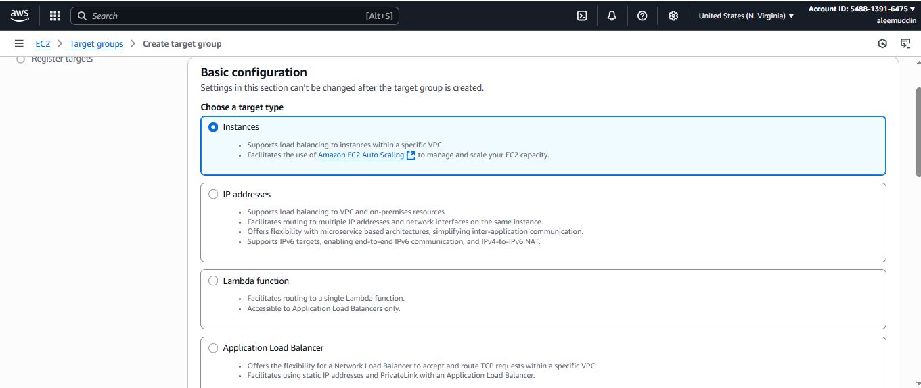

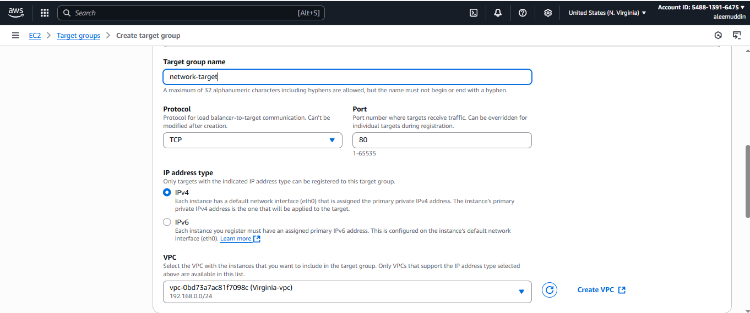

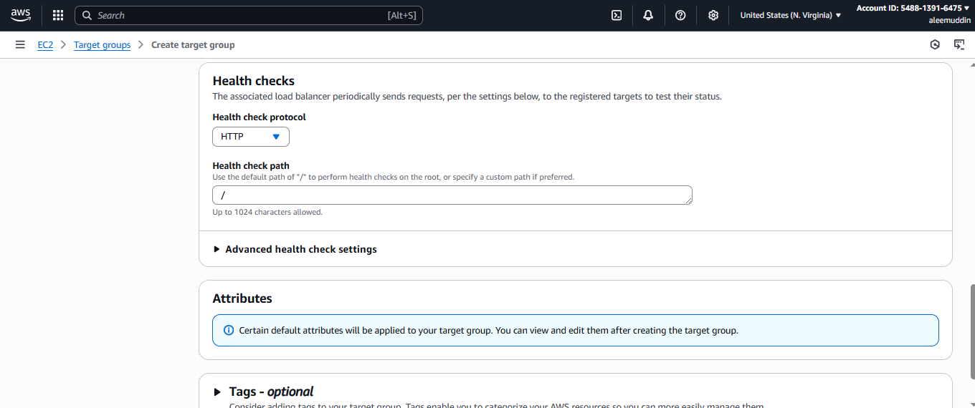

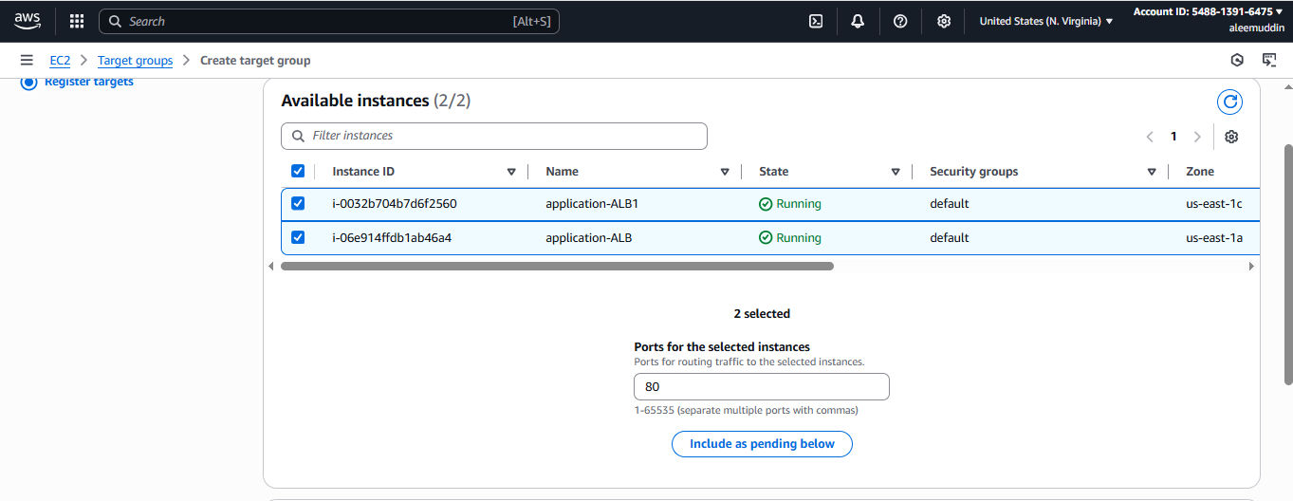

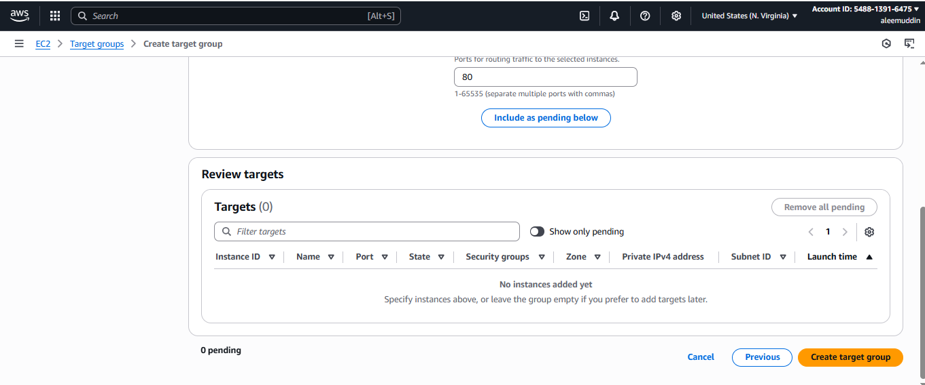

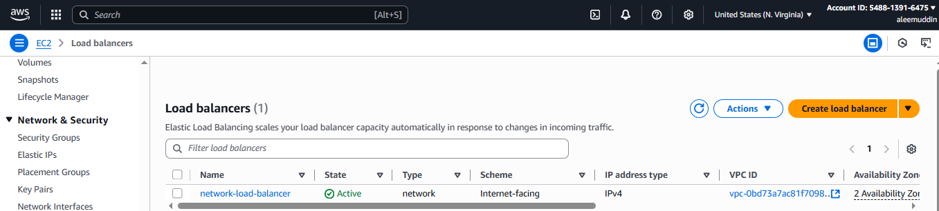

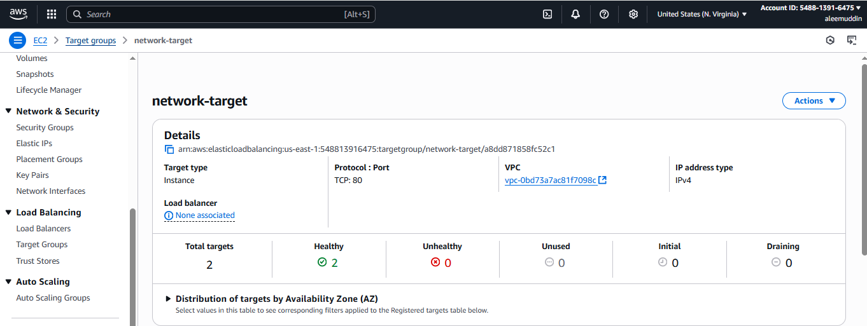

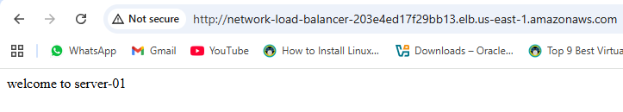

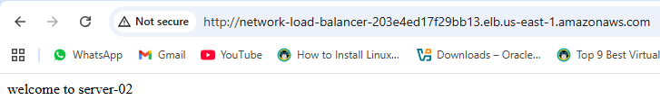

**4) Attach SSL for application load balancer.**

**Create SSL Certificate in AWS Certificate Manager (ACM):**

* **Request a public certificate for yourdomain.com and www.yourdomain.com.**
* **Validate via DNS or email.**

**Edit ALB Listener:**

* **Add HTTPS (443).**
* **Choose the SSL certificate from ACM.**
* **Set default action to forward to your target group.**

**Save Changes.**

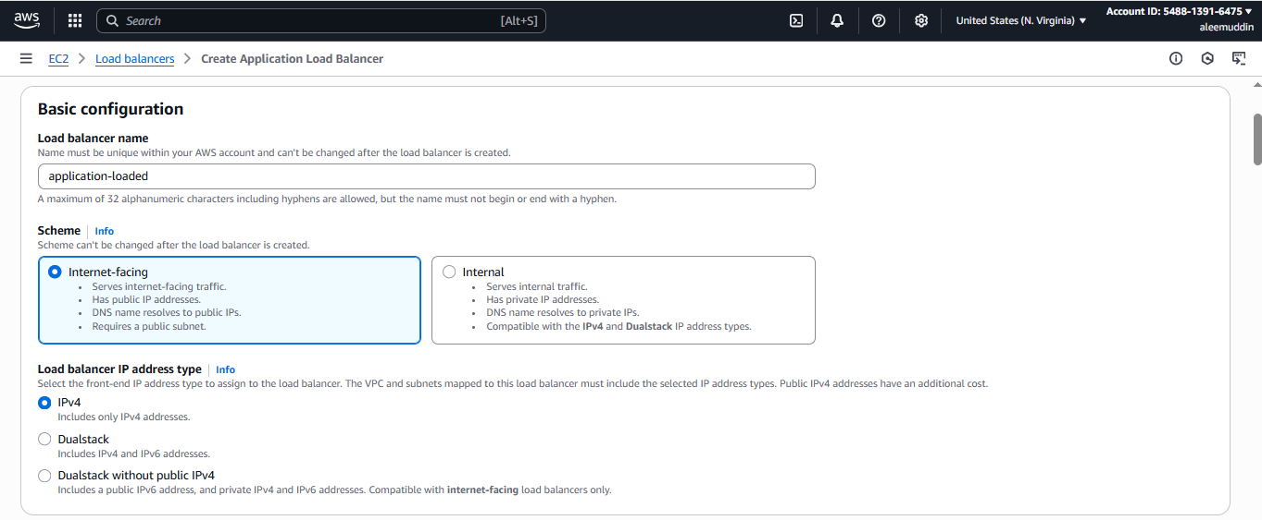

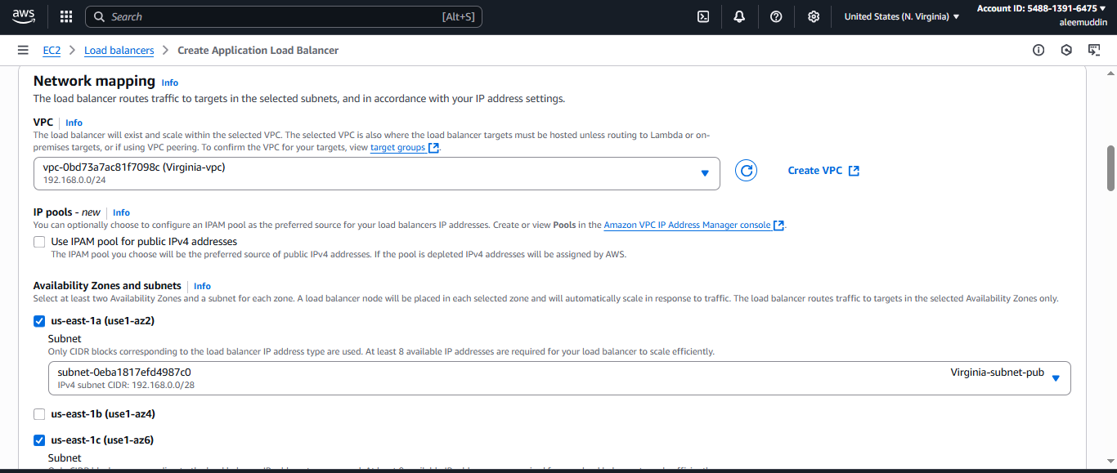

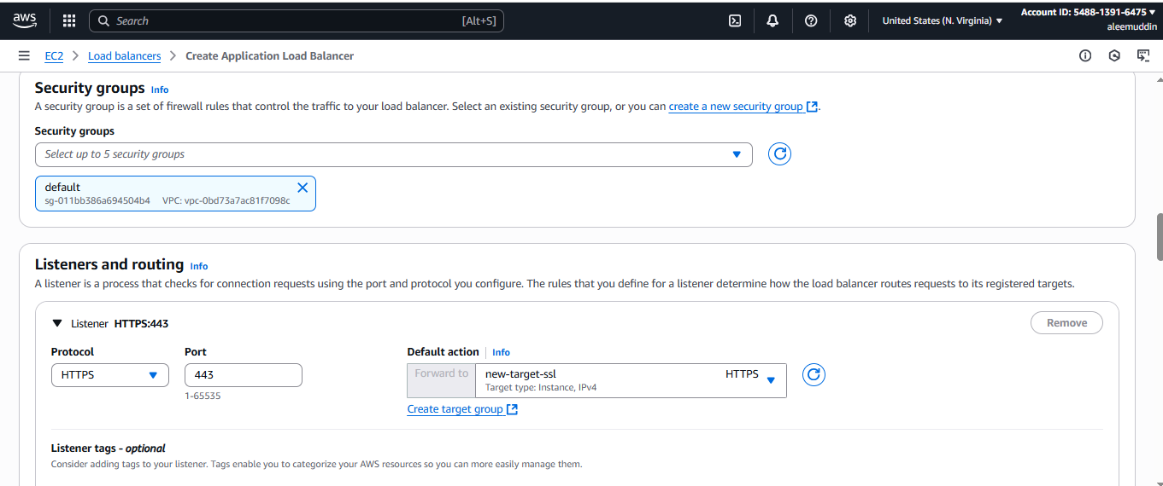

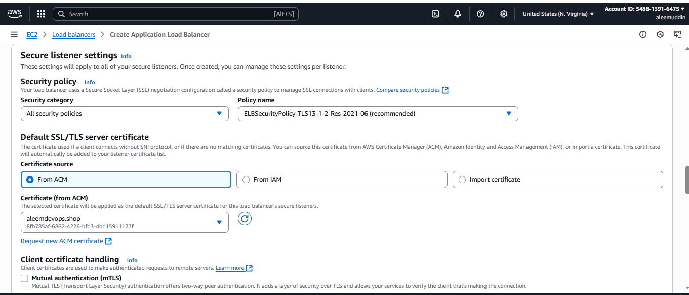

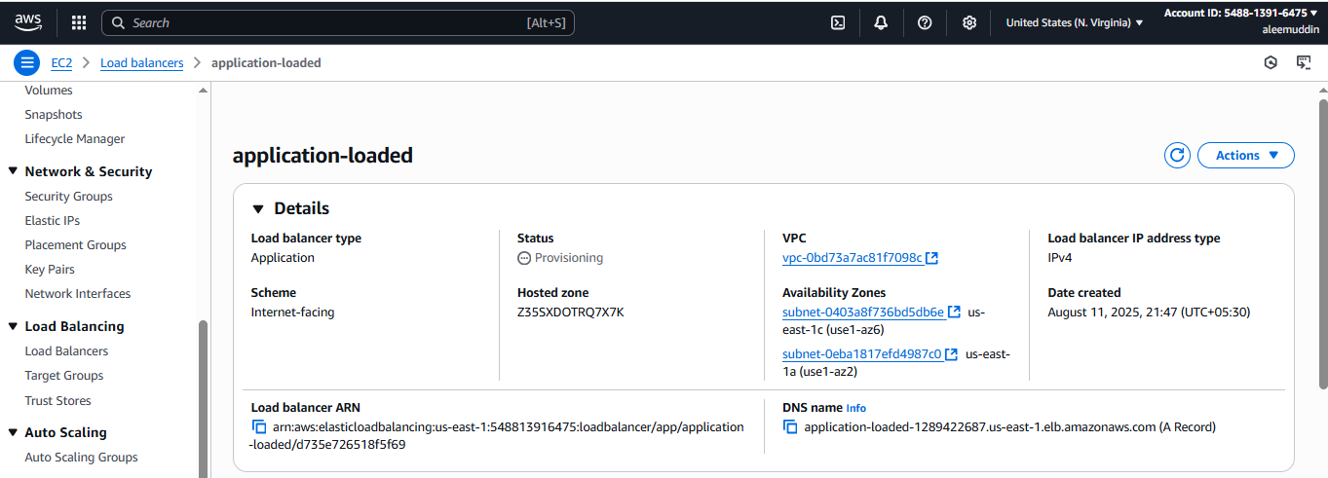

**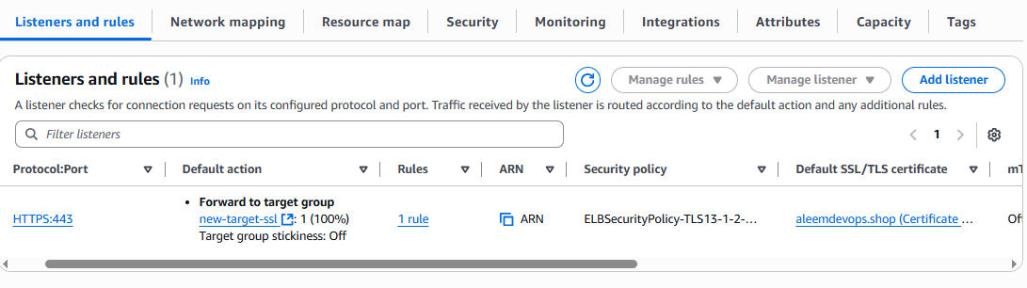  
5) Map Application load balancer to R53.**

**Go to Route 53 → Hosted Zones → Select your domain.**

**Create Record:**

* **Record type: A (Alias).**
* **Alias: Yes.**
* **Select your ALB from the drop-down list.**

**Save Record.**

**Now, yourdomain.com will point to the ALB.**

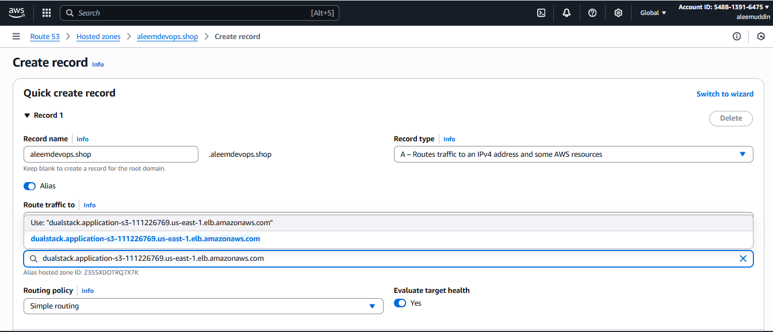

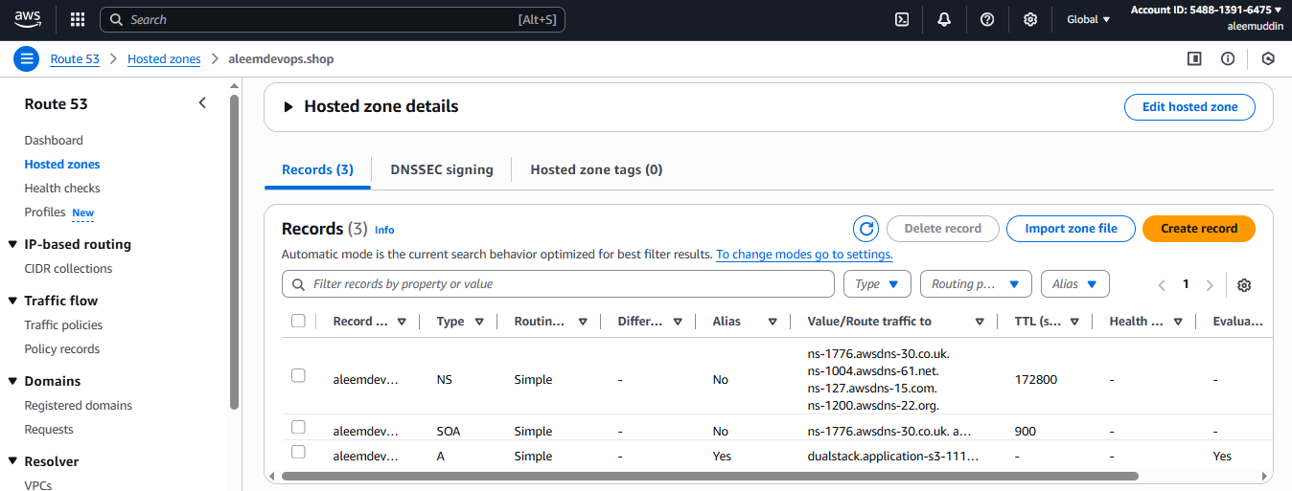

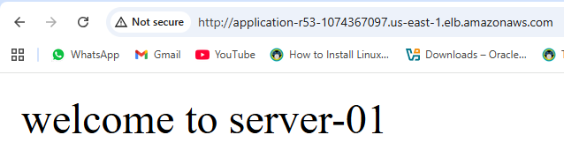

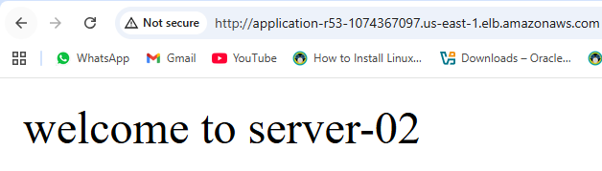

**6) Push the application load balancer logs to s3.**

**Create S3 Bucket:**

* **Example: alb-logs-myapp.**
* **Disable public access, enable versioning if needed.**
* **Create policy → got to permissions → edit bucket policy.**

**{**

**"Version": "2012-10-17",**

**"Statement": [**

**{**

**"Effect": "Allow",**

**"Principal": {**

**"AWS": "arn:aws:iam::127311923021:root"**

**},**

**"Action": "s3:PutObject",**

**"Resource": "arn:aws:s3:::imran-s3-alb-logs/AWSLogs/483591332684/*"**

**}**

**]**

**}**

**Enable Logging in ALB:**

* **Select ALB → Attributes tab → Edit → Enable Access Logs.**
* **Choose the S3 bucket.**
* **(Optional) Set a prefix for logs.**

**Save — Logs will start appearing in S3 in ~5 minutes.**

